We have found several problems in a phantom simulation. This simulation was previously validated with FLUKA and MCNP5, [F. Botta, A. Mairani, G. Battistoni, M. Coca Perez, M. Cremonesi, R. Hobbs, M. Pacilio, K. Parodi, G. Sgouros, A. Vergara Gil, “Customization of FLUKA Monte Carlo code for dosimetry on PET-CT and SPECT-CT images: comparison with EGS-based 3D-RD and MCNP5”, Journal of Nuclear Medicine 53(S1), May 2012, 1497]. Following a description of the issues:

* Dose profiles using an analitical phantom does not match with the voxelized one [analitical phantom is te one simulated with Gate using cilinders and gps sources; voxelized phantom is the one simulated with Gate using mhd images for both geometry and sources].

Analitical phantom

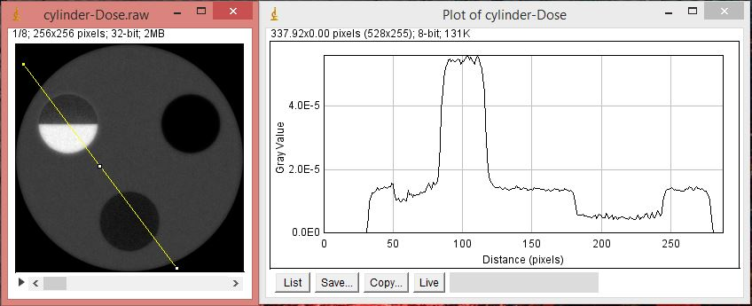

voxelized phantom

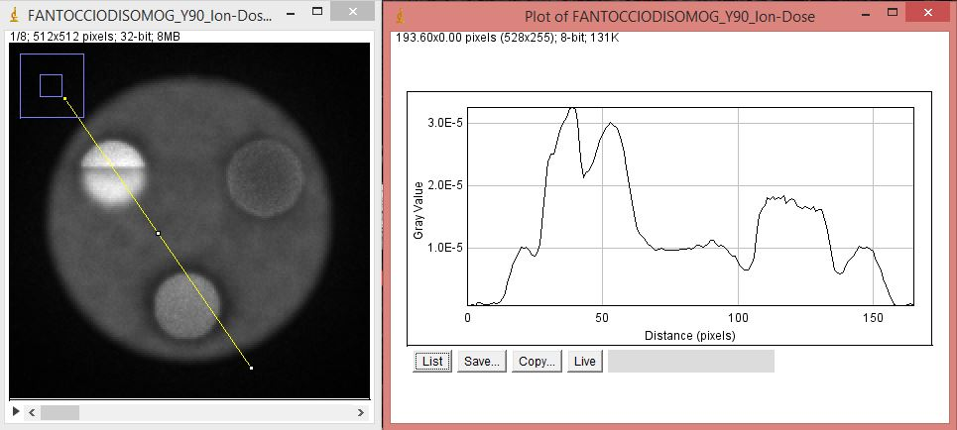

analitical phantom

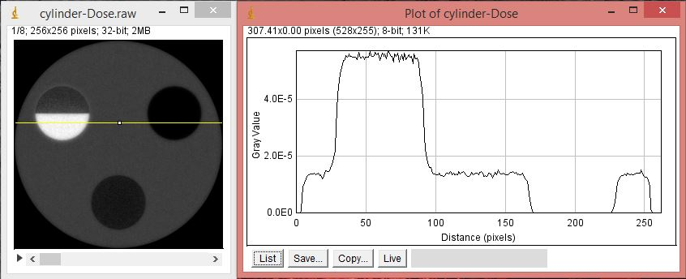

voxelized phantom

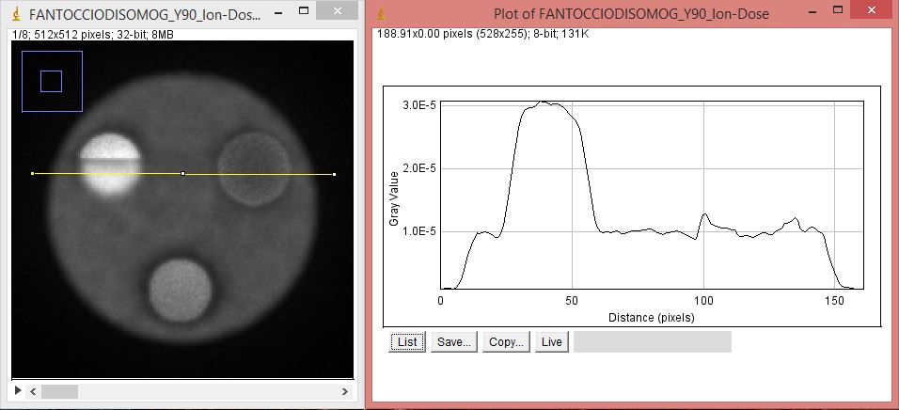

* A posible explanation for the last issue shall be the non match between voxel densities read by the voxelized geometry range translator. The dose equals Edep/voxel mass for both the analitical and voxelized sources so this may not be the problem. Although you can see a discrepancy in the top right cilinder and in the water – air interface.

Edep/voxel mass

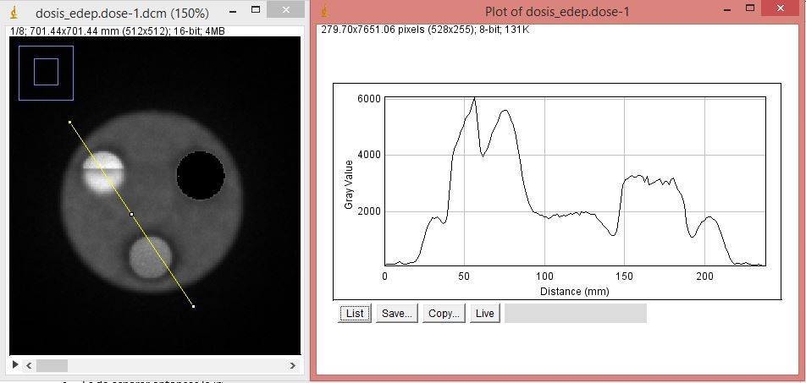

dose

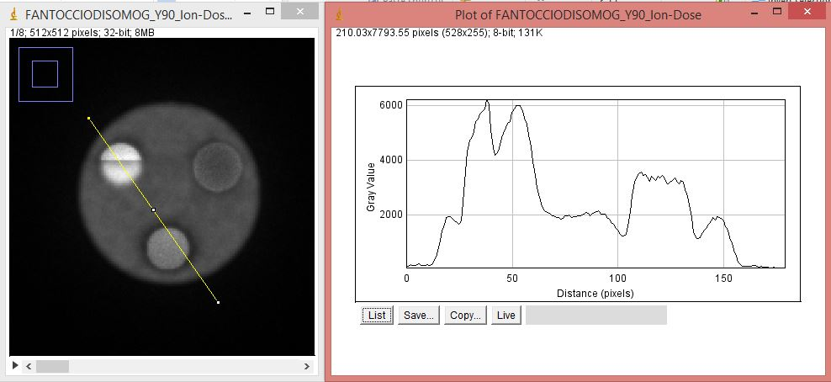

Edep/voxel mass

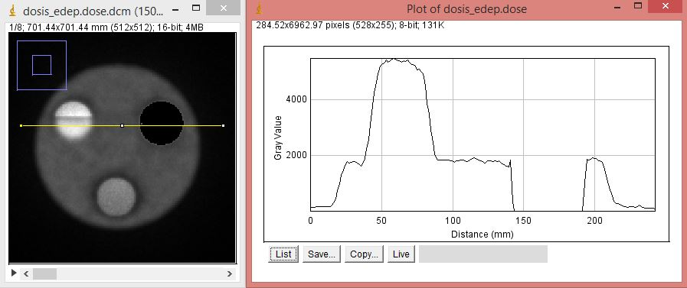

Dose

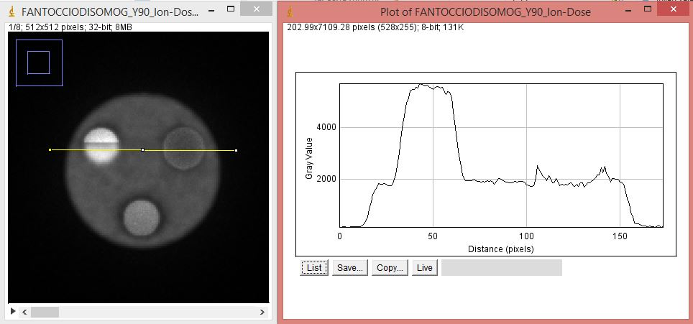

* The calculated Edep/mass image does not match with the already published one using FLUKA.

Edep/voxel mass



FLUKA results

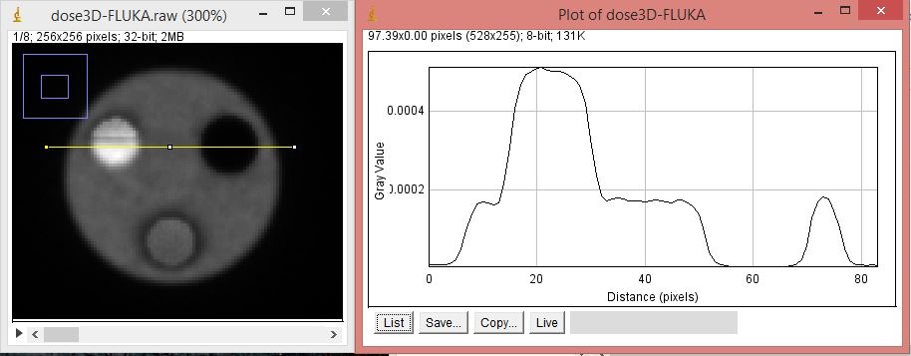

Edep/voxel mass



FLUKA results

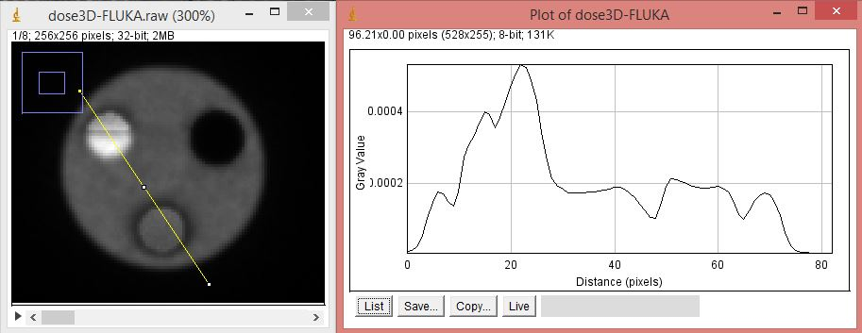

* The dose image also does not match with the FLUKA one

Dose image



FLUKA dose image



Dose image



FLUKA image

